4,6,10,Slack
Program 3: Create a maven projects with all dependencies required for the application in CI/CD pipeline.

MAVEN PROJECT:
Step1:
Open Eclipse
File -> new-> maven project ->next
Choose maven-archetype-quickstart -> version 1.1 or 1.4
Group id nd artifact id anything, Artifact nd package name should be same
In chrome, search maven repository
Search json simple
1st json.simple
Click the one which has more usages. 1.1.1
In the maven u will have, there will be dependency code
pom.xml paste the dependency code
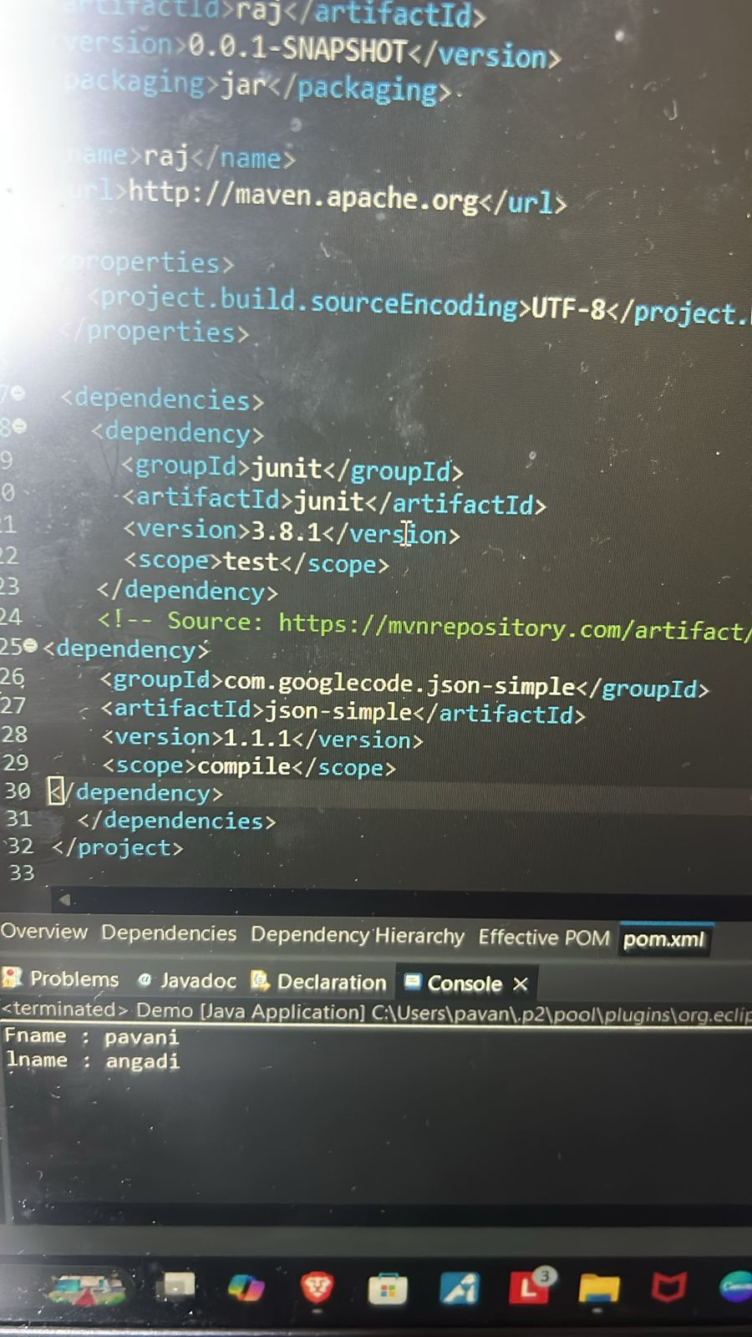
Right click on package -> new -> file -> filename: any.json
Code to put in .json file:
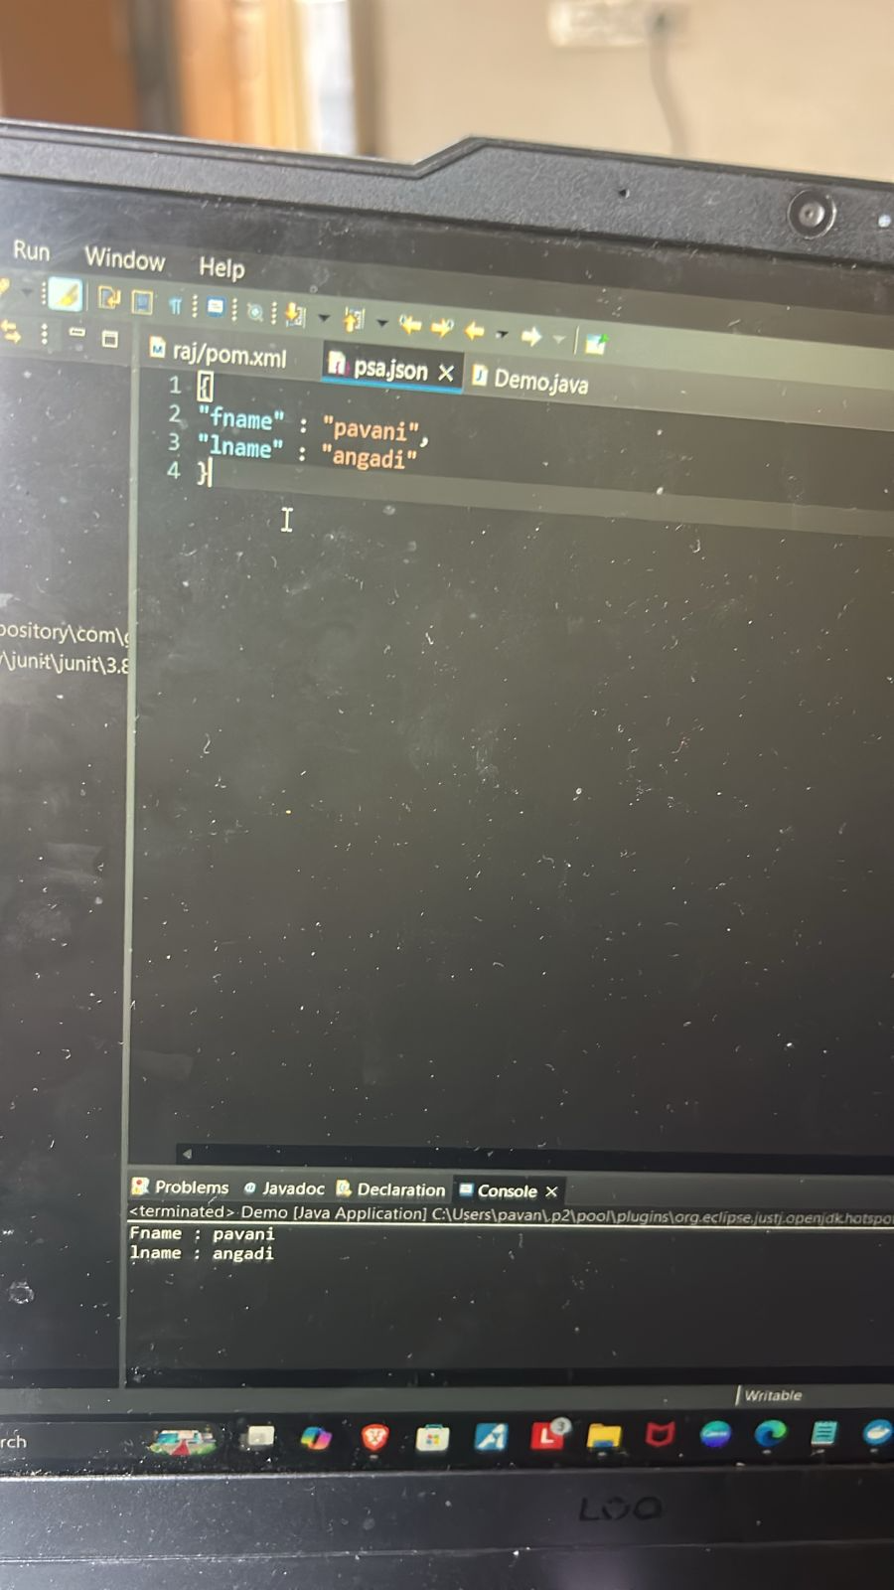
Right click on src/test/java
New-> class -> Demo.java
Code to put in Demo.java:
import java.io.FileReader;

import org.json.simple.JSONObject;
import org.json.simple.parser.JSONParser;

public class thoju {

public static void main(String[] args) {

JSONParser p = new JSONParser();

try {

Object obj = p.parse(new FileReader("san.json"));

JSONObject jo = (JSONObject) obj;

String fname = (String) jo.get("fname");
String lname = (String) jo.get("lname");

System.out.println("Fname : " + fname);
System.out.println("lname : " + lname);

}
catch (Exception e) {
e.printStackTrace();
}
}
}

Save and run

1st Program:
Create a folder nd open in vs code
Create Dockerfile
Content in Dockerfile:
FROM eclipse-temurin:21-jdk
WORKDIR /app
COPY . /app
RUN javac prime.java
CMD ["java","prime"]

Put the java file name instead of prime

Create .java file
Write any apln code
Save

Run these 2 commands in terminal:
docker build -t h1 .
//where -t h1 is image name
docker run image-name
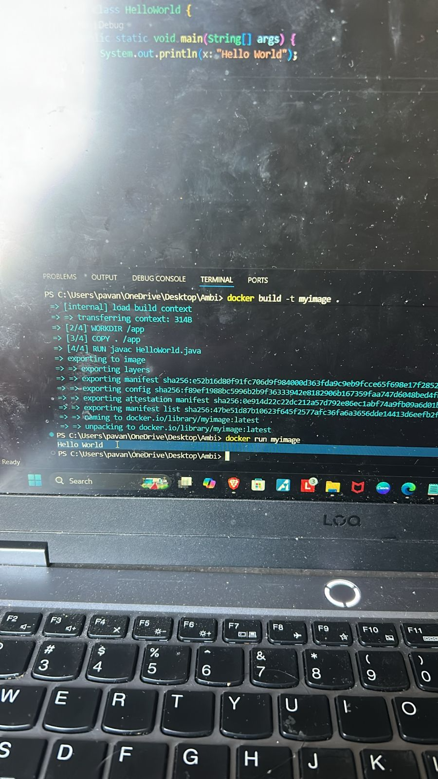

Output : 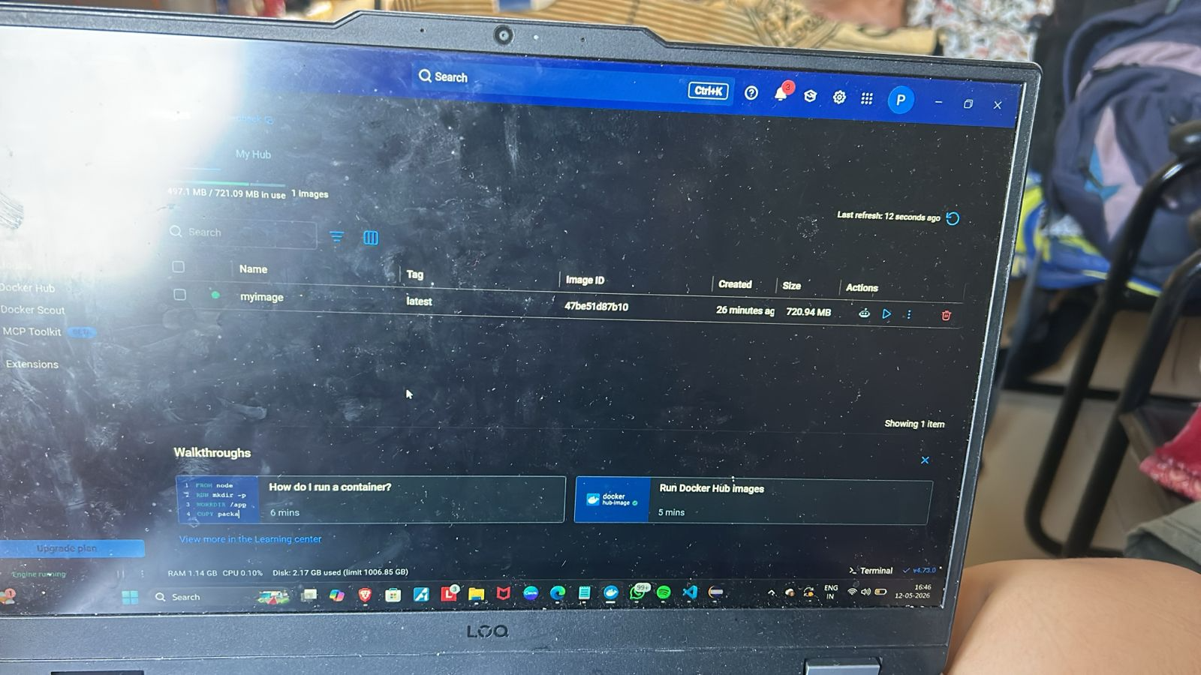

Docker hub should be running-> engine should be running
Image should be in docker desktop

2nd Program: Create and configure Jenkins files for workflow and build of an application and push the image

Create a new repo in github
Create a Dockerfile with the content:
FROM eclipse-temurin:21-jdk
WORKDIR /app
COPY . /app
RUN javac prime.java
CMD ["java","prime"]

Create a java appln file (say Hello.java)
Create a Jenkinsfile with the content:
pipeline {
agent any

environment {
DOCKERHUB_CREDENTIALS = 'Docker-credentials'
IMAGE_NAME = 'pannu27/new_docker_image'
}

stages {

stage('Build Java Application') {
steps {
bat 'javac prime.java'
}
}

stage('Run Java Program') {
steps {
bat 'java prime'
}
}

stage('Build Docker Image') {
steps {
bat 'docker build -t %IMAGE_NAME%:latest .'
}
}

stage('Login to DockerHub') {
steps {
withCredentials([usernamePassword(
credentialsId: 'Docker-credentials',
usernameVariable: 'USER',
passwordVariable: 'PASS')]) {

bat 'echo %PASS% | docker login -u %USER% --password-stdin'
}
}
}

stage('Push Docker Image') {
steps {
bat 'docker push %IMAGE_NAME%:latest'
}
}
}
}

Go to Jenkins -> manage credentials -> add credential -> username p.w
Give username nd p.w of dockerhub and click Create
Jenkins->new item -> pipeline project -> ok
Select pipelinescript from scm
Scm -> select git
Add git repo link
Add credential
Branch -> main

Apply and save
Click on build now
It should show green check with all the stages being completed
Image will be showed in docker hub

4th program: slack
Open Jenkins
Open slack.com
It should show welcome to lab practice
Create new channel
More -> tools-> apps -> search Jenkins -> open app -> configure -> add to slack -> select channel nd integrate -> go to step3 -> copy the token
Go to Jenkins
Available plugins -> select slack notification and global slack notifier and install them.
No need to restart Jenkins
Go to settings -> manage Jenkins ->system ->slack
Workspace : csections-workspace
Credentials: Add -> global -> secret text (the token u copied) ->id:anything and then create
Click drop down nd select the credential
Test connection -> should show success
Apply and save

Click on new item
Select free style project -> ok
Build steps: Add build steps -> execute windows batch command -> java –version

Post build actions:
Add post build action -> slack notifications
Select:
Notify build start
Notify success
Notify abort
And then click on build now

